**Part1: Introduction & Background**

**EVM**

EVM stands for Eulerian Video Magnification. As per the paper **”** **Eulerian Video Magnification for Revealing Subtle Changes in the World**“ presented by William Freeman, Fredo Durand, John Guttag, Eugene Shih, Michael Rubinstein and Hao-Yu Wu :-

“Our method, which we call Eulerian Video Magnification, takes a standard video sequence as input, and applies spatial decomposition signal, followed by temporal filtering to the frames. The resulting signal is then amplified to reveal hidden information.”

As per the paper EVM relies on a linear approximation related to the brightness constancy assumption used in optical flow. So the result was:-

“Using our method, we are able to visualize the flow of blood as it fills the face and also to amplify and reveal small motions.”

EVM can be applied to color variation and low-amplitude motion but requires different processing techniques.

EVM takes inspiration from Eulerian perspective, which varies from Lagrangian perspective.

* LAGRANGIAN PERSPECTIVE :- **It is in reference to fluid dynamics where the trajectory of particles is tracked over time. And it relies on accurate motion estimation and other additional techniques, including motion segmentation, image in-painting, and are required to produce good quality synthesis.**
* EULERIAN PERSPECTIVE :- **It is properties of a voxel of fluid, such as pressure and velocity, evolve over time. We amplify the variation of pixel values over time, in a spatially-multiscale manner. We do not explicitly estimate motion, but rather exaggerate motion by amplifying temporal color changes at fixed position.**

So from above we can infer that Eulerian perspective is an easier method. The diagram below shows the necessary steps required for Eulerian video magnification:-

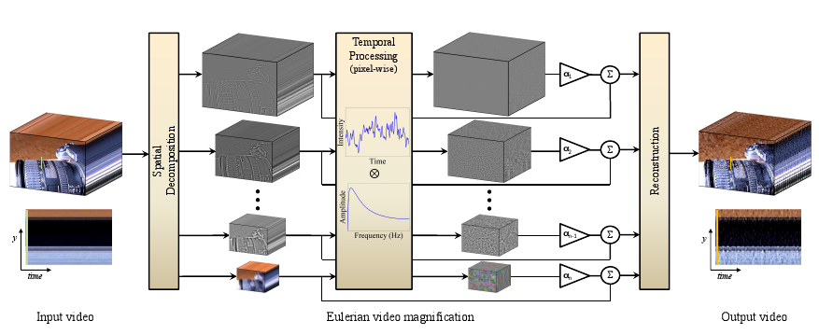

Steps to be followed:-

1) Perform a spatial frequency decomposition. For each band they might be magnified differently because :- a) they might have different S/N ratios b) they might contain spatial frequencies for which the linear approximation used in the motion magnification does not hold.

If the goal of spatial processing is simply to increase temporal S/N ratio by pooling multiple pixels, we spatially low-pass filter the frames of the video and simply downsample them for computational efficiency.

2)Step to be taken after selecting the frequency band :-

a) Select a temporal bandpass filter.

b)Select an amplification factor α.

c)Select a spatial frequency cutoff(specified by spatial wavelength λ beyond which an attenuated version of α is used.

d) Select the form of the attenuation for α i.e., either force α to zero for all frequency less than λ , or linearly scale α down to zero.

3) Adding the magnified signal to the original and collapse the spatial pyramid will get us to the final result.

**SPATIAL DECOMPOSITION**

For spatial decomposition Gaussian pyramid or Laplacian pyramid can be used. We have used Laplacian pyramid in our project (with Gaussian pyramid on standby). Based on performance we have found out that Laplacian is giving better outcome. The images are read from a video frame by frame and is processed. Each frame is then reduced by a factor of 2 and are passed on for further processing. After that they are expanded back to the original size of the frame.

**TEMPORAL FILTERING**

So, we just assume that after the filter we can get the desired frequency( We assume that the pixel color changes along with the desired properties, i.e. human breath 60 times a minute, we assume the pixel color has the similar behavior)(The paper said if not so we can separate it out and amplify the individual frequency separately).

We have used and Ideal band pass filter for our purpose. But it is worth noting that Butterworth, IIR Second order filter etc., can also be used. We have test with other filters as well.

**COMBINE**

After getting the desired band of frequency from the image, we amplify the signal by an amplification factor α. For our purpose we have taken α=50. We still need to test with other values. After amplifying expand the image using Laplacian pyramid structure to its original size.

**Part2: Progress so far**

So far, we have finished EVM implementation. And this is done in java as opposed to C++ as we proposed. The following section contains details of source code we have implemented and some problem we are facing. Because of the problem, we are now not able to get do overall test of our program yet. Thus, results are not available currently.

**SOURCE CODE**

We have implemented modules in java for the time being. If we get a performance impact we plan to re-implement in C++.

It has 4 modules in it:

1) Video Processing:- We have used jcodec 0.1.9 jar for video processing. It converts the video stream into frames for future processing. Apart from jcodec 0.1.9 jar no other library is used for any of the modules.

2)Spatial Decomposition :- It has Gaussian and Laplacian implementations as java class files. It is used to reduce and expand the image frames.

3)Temporal Filtering :- It is by far the most important and complex module of this project. It contains files for FastFourierTransformation(to convert images to frequency domain), FrequencyFilter(to filter out unwanted frequency,which uses ideal bandpass filter) and ComplexNumber(to denote real and imaginary part of Fourier Transformation)

4)Amplification :- This module has files for Amplification(which amplifies the desired frequency after temporal filtering) and ScaleImage(which expands the reduced image to its original size).

**Problems**

1) We know that FFT converts images to frequency domain. We still have to figure out as to for what is the range of frequency we need to filter. It will require a thorough research from our end as we are planning not to use libraries for our project.

**Part3: Revised research plan**

As we have proposed, aside from face detection, we also need to implement Viola-Jones face detector and micro-expression to make the whole program as a lie detector. The work distribution among our group is listed as following:

**Work distribution**

|  |  |  |
| --- | --- | --- |
| Name | 04/09/16-04/15/16 | 04/16/16-04/22/16 |
| Debasis Dwivedy | Solve frequency filtering problem in EVM | Merge code with others and test lie detector |
| Achyut Boggaram | Implement microexpression program | Merge code with others and test the lie detector |
| Furu Zhang | Implement Viola Jones program | Merge code with others and test the lie detector |

**Part4: References**

**References**

[1] Wu, Hao-Yu, et al. "Eulerian video magnification for revealing subtle changes in the world." (2012).

[2] Liu, Ce, et al. "Motion magnification." *ACM transactions on graphics (TOG)* 24.3 (2005): 519-526.

[3] Rubinstein, Michael, et al. "Revealing invisible changes in the world." *Science* 339.6119 (2013): 519-519.

[4] Wadhwa, Neal, et al. "Phase-based video motion processing." *ACM Transactions on Graphics (TOG)* 32.4 (2013): 80.

[5] Wadhwa, Neelanshi, et al. "Riesz pyramids for fast phase-based video magnification." *Computational Photography (ICCP), 2014 IEEE International Conference on*. IEEE, 2014.

[6] Durand, Frédo, William T. Freeman, and Michael Rubinstein. "A World—of—Movement." *Scientific American* 312.1 (2015): 46-51.

[7] Elgharib, Mohamed A., et al. "Video magnification in presence of large motions." *Computer Vision and Pattern Recognition (CVPR), 2015 IEEE Conference on*. IEEE, 2015.